1. LCD display 185 RS

<https://www.google.com/search?q=lcd+display&rlz=1C1CHBF_enIN857IN857&source=lnms&tbm=shop&sa=X&ved=0ahUKEwiP1LHMtcjjAhWJX30KHQXcAE8Q_AUIEigC&biw=1707&bih=821&dpr=0.8#spd=4517100805133380275>

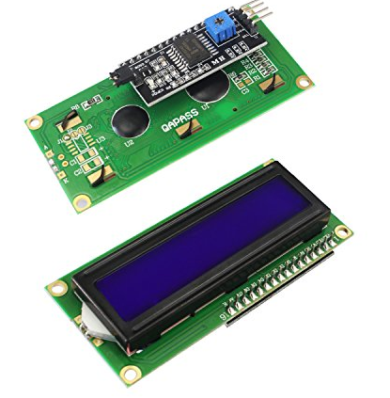

1. NodeMCU V3 (ESP8266 12E):- 354RS

<https://www.amazon.in/Adraxx-Entdev019-Esp8266-Nodemcu-Development/dp/B01N23NJUG?tag=googinhydr18418-21>

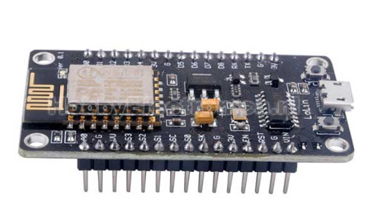

1. Turbidity Sensor for Liquid Suspended Particles Water Turbidity Detection Module Kit:- 1500RS approx

<https://www.amazon.com/Turbidity-Sensor-Suspended-Particles-Detection/dp/B075H91PY1>

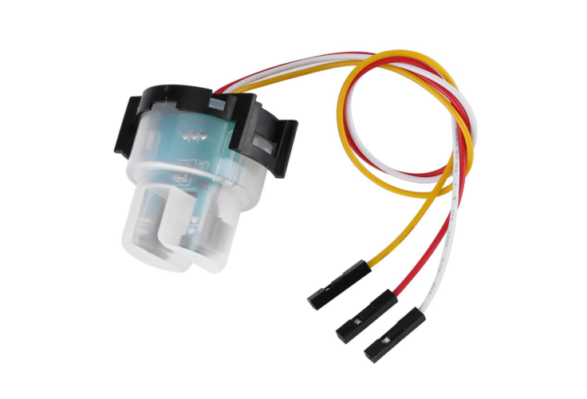

1. Analog PH Sensor Kit: 2649RS  
   <https://robu.in/product/analog-ph-sensor-kit/>

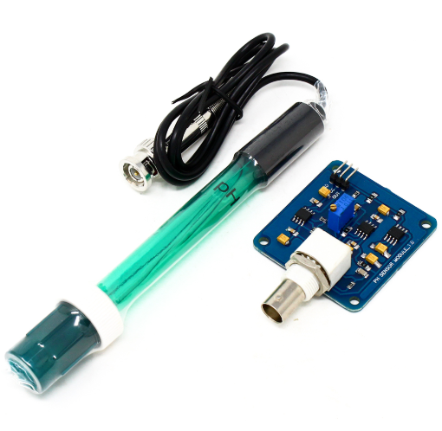

# orp PH Tester ph Pen Test Waterproof ORP/PH Meter https://www.amazon.in/Rrimin-Digit[al-Meter-Tester-Waterproof/dp/B074V8CXFZ?tag=googinhydr18418-21](https://www.amazon.in/Rrimin-Digital-Meter-Tester-Waterproof/dp/B074V8CXFZ?tag=googinhydr18418-21)

